Free digital marketing plan template

Introduction
A dedicated digital marketing plan is an essential tool to compete and grow your business. It gives focus to your digital marketing activities by setting realistic, achievable priorities within your budget. It simply defines what you want to gain from your investment in digital marketing and how you will achieve these goals through selecting the best marketing strategies and channels to acquire and retain customers.

Many marketing plan templates were created long ago for larger businesses and aren’t so relevant to small and startup business competing in today’s marketplace, where effective digital marketing is essential. Long plans with sections labelled ‘mission and vision statement’ and ‘corporate strategies’ are irrelevant for smaller businesses. This template is far more practical since it relates to the real-world challenges and opportunities for smaller and medium-sized businesses. The template shares the key features of our RACE Growth System since it is designed to be:
- Strategic - quick to create and implement an actionable plan with simple steps
- Data-driven - defining SMART objectives based on forecasts
- Practical to implement - using a 90-day planning approach to give you focus and with specific Standard Operating Procedures (SOPs) that you can customize for your business and re-use
- Designed for smaller businesses, but relevant for larger businesses too.

How to use this template
For help in completing this template please reference the accompanying PDF download:
‘How to create a 90-day digital marketing plan’.

This template is designed to be simple and quick to complete, while defining the details needed for a realistic plan.
It’s split into three sections:
- 1. OPPORTUNITY — Where are we now, what do we want to achieve?
- 2. STRATEGY — How will we prioritize investment to achieve our goals?
- 3. ACTION — How will we implement and resource our plan?

Note: this template focuses on a 90-day plan to get started. Our Digital Marketing Toolkit for premium members and the recommended resources in each section have longer-form Word, Excel and PowerPoint workbooks to help you plan, manage and optimize your digital marketing.

About Smart Insights
Since we launched in 2010, we’re proud to have supported the growth of many businesses by reducing their need for costly consultants or agencies. Our self-service Learning Path training platform and actionable templates are aimed at making it quick for you to learn what you need to and then rapidly act on your learnings. Our RACE Growth System provides a simple, yet comprehensive framework to plan, manage and optimize your marketing communications with a focus on the digital marketing activities that are fundamental to future success.

Next steps
We hope this free template helps you quickly summarize your marketing priorities and gives you a solid basis for future growth. We’d love to support you as you refine and implement your strategy with the detailed planning templates recommended for each step.

Our Business Membership gives marketers and business owners a comprehensive library of templates and Learning Paths for a planned, structured approach to all modern marketing channels; from campaign planning and content marketing to search engine optimization and social media.

To learn more, view our plans and pricing or arrange a free consultation and demo.
PART 1. OPPORTUNITY — Where are we now, what do we want to achieve?
Step 1. Digital capabilities and performance audit
A summary of priorities for improvement and current results delivered by digital marketing.

Recommended premium resource: Detailed RACE digital marketing health check audit
[Capability review: Use our digital marketing maturity scorecard featured in the accompanying PDF to score maturity for your business across the 7 pillars of digital marketing].  [Performance audit: choose your top three priorities from the 25 RACE Standard Operating Procedures (SOPs) in the PDF, those are the 3 most important to work on within next 90-days or 12 months] | Capability review  Performance audit – top 3 priorities [example]
  Digital pillar | Score now | Target in 12 months
  1. Marketing and brand strategy | /5 | / 5
  2. Digital marketing strategy | / 5 | / 5
  3. Data and insight | / 5 | / 5
  4. Digital media | / 5 | / 5
  5. Content marketing strategy | / 5 | / 5
  6. Digital experience | / 5 | / 5
  7. Digital messaging | / 5 | / 5
  RACE goal | Now
  PLAN | 1. Create digital strategy since no dedicated digital strategy
  REACH | 2. Digital PR since declining organic search volume
  ACT | N/A
  CONVERT | 3. Improve nurture sequence  (since only single email in series)
  ENGAGE | N/A
Step 2. Digital marketplace review
Opportunities and threats from changes in customer profiles, behaviour, competitor, and digital intermediary activity.

Recommended premium resources: Brand audit and marketplace review template, Competitor benchmarking template
SOPs we need to follow and improve upon include:  - Brand audit  - Digital TOWS  - Competitor benchmarking | We recommend using a detailed TOWS matrix since this is forward-looking by integrating your analysis with your strategy, rather than a backward-looking SWOT. Our 10+ sector specific digital marketing plan examples for premium members give detailed example plans in Word that can be customized.  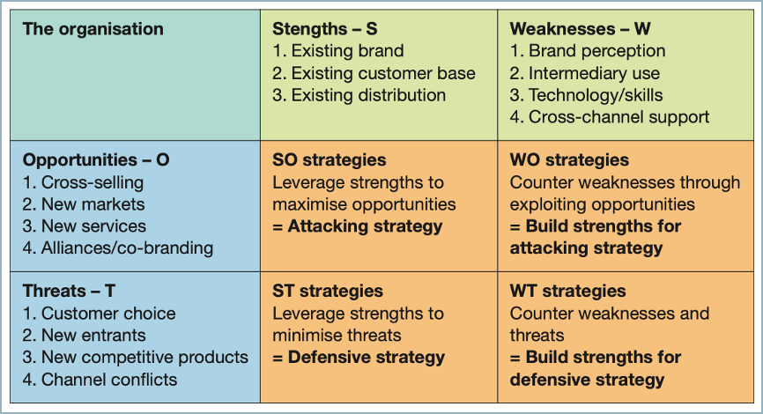
Step 3. Set SMART objectives
Define time-limited, realistic objectives for each part of the customer lifecycle across RACE.

Recommended premium resources: Digital marketing planning spreadsheet, Digital marketing dashboard (Looker)
SOPs we need to follow and improve upon include:  - Forecast digital and multichannel leads/sales  - Set SMART objectives across RACE  - Create digital dashboard | We recommend this matrix format to align objectives and strategies. Examples for different sectors to paste are included in our downloadable Word template examples for premium members. We also provide a conversion model spreadsheet to give a more realistic forecast.  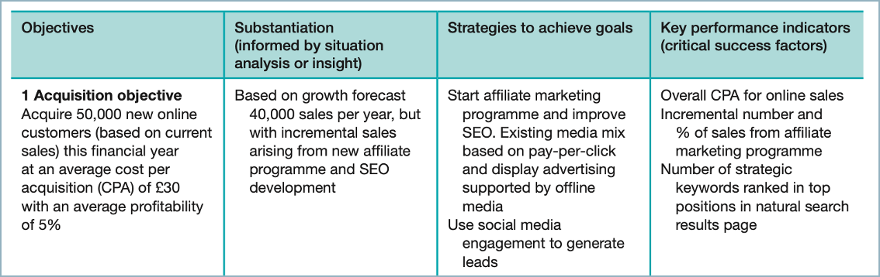

PART 2. STRATEGY — How will we prioritize to achieve our goals?
Step 4. Our digital brand – refining STP: Segmentation, Targeting and Positioning
Priority improvements to refine your brand and targeting for more effective digital communications.
Recommended resources: Customer persona guide and template (B2B and B2C) and Brand positioning template
[Select priorities from activities in 5X5 RACE grid SOPs we need to follow and improve upon include:  - Create actionable  multichannel personas  - Select media targeting options  - Update brand positioning including brand-tone of-voice  - Digital value proposition] | Top three priorities and SOPs we need to improve:  - P1.  - P2.  - P3.  Check personas go beyond top-level thumbnails to include digital-offline customer journey maps. Key sections:  - Demographics and personal situation  - Psychology and behaviour  - Content and customer journey maps  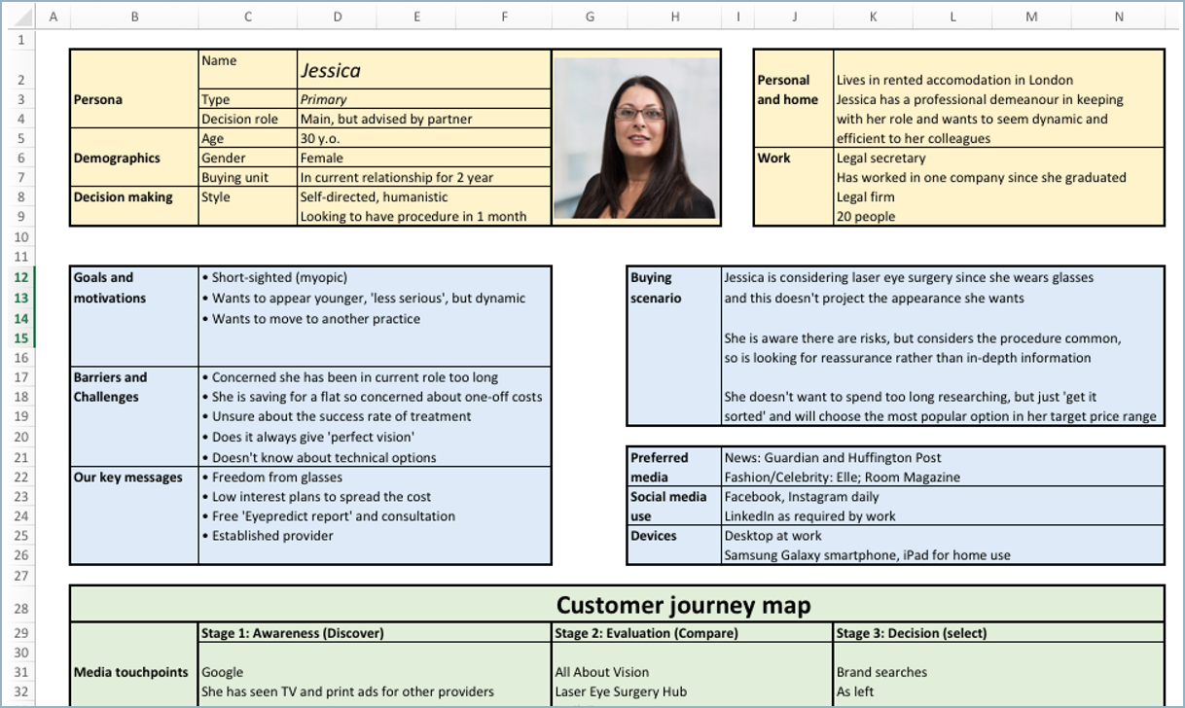
Step 5. How we manage digital marketing
Changes we need to make to how we manage marketing to make better use of digital marketing?

Recommended resources: AI Governance Playbook, Digital marketing Centre of Excellence best practices ,
Website conversion optimization planner
[Select priorities from activities in 5X5 RACE grid – examples  • Improve digital dashboard  • Structured testing programme  • Implement 90-day planning  • Implement 90-day planning] | Top three priorities and SOPs we need to improve:  - P1.  - P2.  - P3.
Step 6. How we improve our always-on and campaign digital communications
Our priorities for improving inbound, always-on and campaign communications,
Recommended resources: Managing SEO Playbook, Email sequence contact strategy template,
Optimize Facebook, Instagram, LinkedIn and TikTok guides
[Select priorities from activities in 5X5 RACE grid – examples  • Improve SEO targeting  • Improve email nurture series] | Top three priorities and SOPs we need to improve:  - P1.  - P2.  - P3.

PART 3. ACTION — How will we implement and resource our plan?
Step 7. Marketing budget and resource plan
A monthly forecast of media, agency, MarTech and staff spending.
Recommended resource: Marketing budget spreadsheet template
Often digital budgets focus on media, but for balance the other pillars of always-on should be covered.  Capital expenditures involves spending on assets or resources that will have a long-term benefit, typically written-off over more than one financial year including MarTech platforms, branding or website redevelopment.  Operating expenditures are ongoing expenses required to run day-to-day marketing operations including media costs, staff costs, agencies, freelancers and subscriptions. | Budget covering the six pillars of digital marketing based on a more detailed budget like our spreadsheet template.  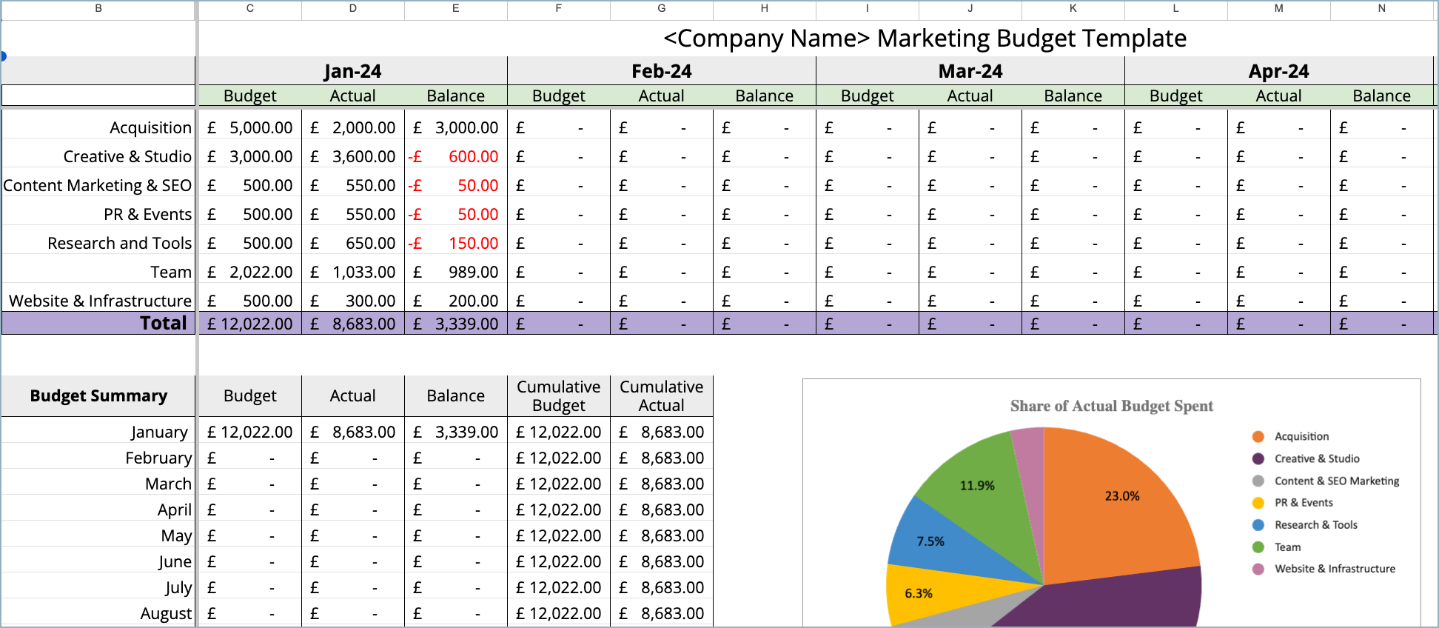
  Budget element | CapEx | OpEx | Total
  1. Media
  2. Content
  3. Experience
  4. Messaging
  5. Planning and management
  6. MarTech
  Total
Step 8. Campaign plan process
A standard, repeatable process for each campaign will improve efficiency results.

Recommended resources: Marketing campaign template, Editorial calendar spreadsheet, Campaign timeline/project plan template
Example SOPs to improve (covered in our template) include:  - Campaign goals and tracking  - Target audience and targeting  - Key campaign messages and offers  - Content assets  - Media plan and budget  - Campaign editorial plan | Top three priorities and SOPs we need to improve:  - P1.  - P2.  - P3.
Step 9. 90-day action plan summary
Select the priority activities for next and following quarters for campaigns, media, content, and website.

Recommended resource: 90-day RACE action plan template and Google SERPs analyzer dashboard for SEO, media,
Example SOPs to follow and improve upon include:  - 90-day planning process  - Review digital marketing dashboard  - Review Google Search Console | Top three priorities and SOPs we need to improve:  - P1.  - P2.  - P3.

Next steps?

We hope you’ve found this template helpful in creating your 90-day digital marketing plan.

To create and implement a more detailed plan using our 70+ Standard Operating Procedures (SOPs):
- Explore our resource library
- Learn more about membership
- Book a free consultation

End of document.

